Step 1 – Create A CSV File that Describes Your Categories

The first line of your CSV file must have the headers: “category”, “description”, and “parent” as shown below…

In this example, “Kingdom” [on the second line of this CSV file] is the top-most category and has no entry in either the description (2nd) column or the parent (3rd) column.

So the 2nd line is “Kingdom,,”

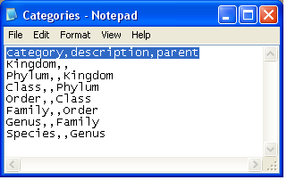

This CSV file should result in the following hierarchy of categories:

Kingdom
|-Phylum
|-Class
|-Order
|-Family
|-Genus
|-Species

Step 2 – Navigate to http://<server-name>/tiki/tiki-admin_categories.php and use the “Batch upload” panel to select your Category CSV file and upload it to your Tiki…[replace <server-name> with the name of your server, such as “localhost”]

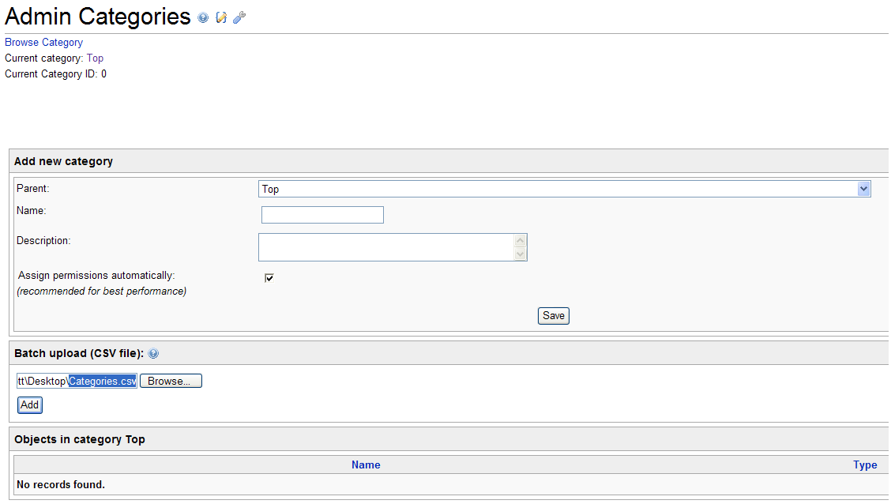
Use the “Batch upload (CSV file): panel to select your CSV file (Step 1) and click then click the “Add” button…
Step 3 – Verify that your new categories have been created…

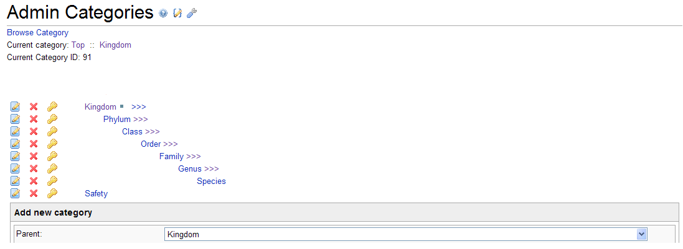
Your new categories should now display in the Admin Categories screen. Initially, the top-most category may be the only one that is visible. To see the sub-categories, just click the triple greater-than symbols “>>>” that appear to the right of each of your parent categories in the hierarchy.

